Title: "World in Figures: Unveiling Development Trends through World Bank Indicators"

Name: Ahsan Farooq

Abstract: This thorough research provides important insights into the social, economic, and environmental landscapes by revealing complex patterns and trends across a range of indicators. The visual aids offer a sophisticated viewpoint, appealing to stakeholders, scholars, and politicians who are interested in comprehending the intricate relationships that are forming our globalized society. Discover the intricate web of global indicators with the help of engrossing graphics and perceptive data storytelling.

# Introduction

This comprehensive data visualization and analysis delve into three key indicators—mortality rate, total population, and cereal yield—offering a nuanced understanding of their interplay and impact on the socio-economic landscapes of diverse regions. Drawing on indicators-based data from reputable sources such as the World Bank, the study aims to uncover trends, disparities, and potential correlations across these vital metrics.

# Population Statistics Comparison

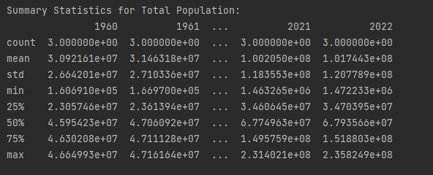

Total population statistics country wise comparison over the years, this is the combine population for France, Pakistan and Bahrain.

# Mortality Rate – France vs Nepal vs Australia

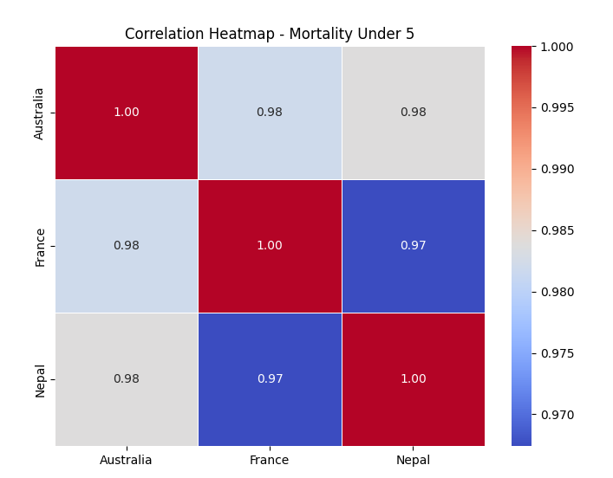

Correlation heatmap to provide the correlation between the mortality rate of different countries. In the world bank data, it is essential to analyze such indicators.

# Year by Year Comparison

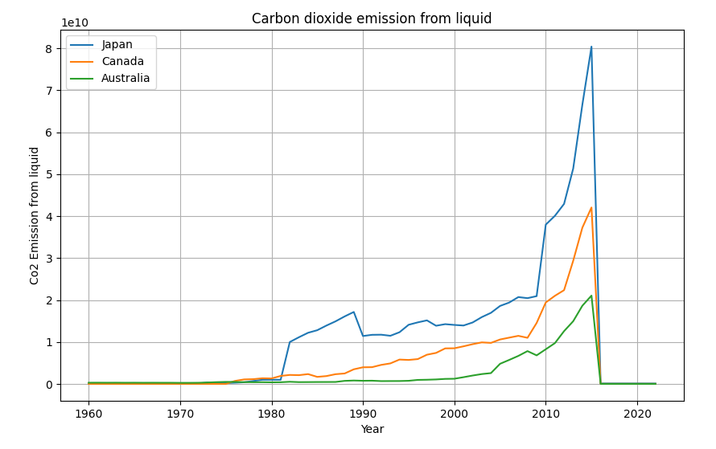

The dynamics of carbon dioxide emissions from liquid fuels in Australia, Canada, and Japan are shown in this powerful line graph. Out of the three, Japan's line is the most conspicuous since it peaked after 2010 and shows the greatest emissions. Australia's line, at the bottom, on the other hand, shows a significant drop in emissions even after 2020, a sign of strong environmental activities.

# Cereal Yield Pie Chart Distribution

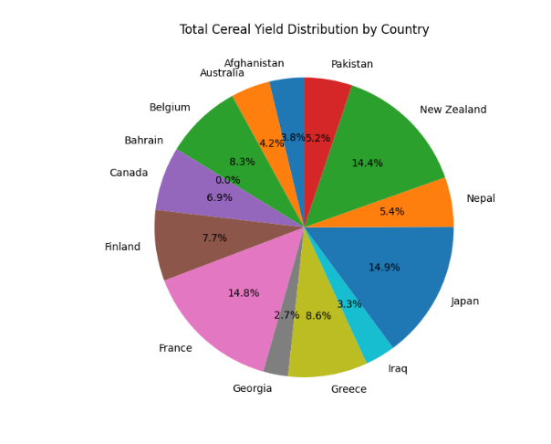

The global distribution of total cereal yield throughout nations is well represented by the pie chart. A clear picture of the relative importance of various countries in the global grain production landscape is given by each slice, which indicates the contribution of that country to the total production.

# Electricity Production – France Vs Belgium

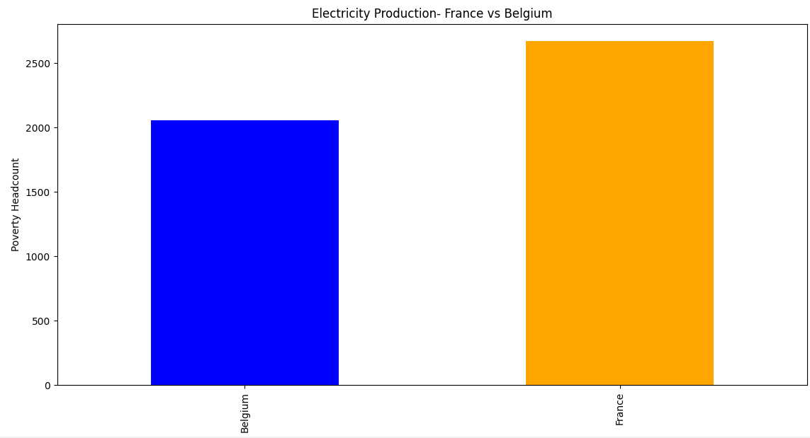

Electricity production from different sources comparison was made between France and Belgium using bar graphs.